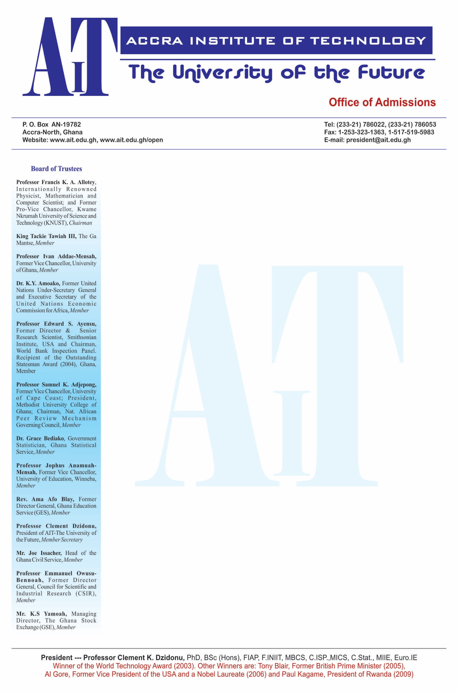

**COURSE: RESEARCH METHODOLOGY**

**COURSE CODE: IT306**

**GROUP MEMBERS:**

1. SOLOMON YEBOAH – ADS21B00223Y
2. FRIMPONG ARNOLD -
3. JEFFERY ADAMS -
4. EMMANUEL GYAN -
5. PROPOSED RESEARCH TOPIC:

Computerized Patient Diagnosis System

B. BACKGROUND OF THE RESERACH:

The background of the research is to reduce the problem of medical diagnosis and to increase its reliance computerized patient diagnosis in development to assist physicians or doctor in diagnosing. This is to retrieve a quick information about patient, provision of efficient medical services.

The project is designed to give access to authority users and also it is designed in such a way that patients must be registered before they can be diagnosed.

C. STATEMENT OF THE PROBLEM:

This is to investigate how effectiveness and efficiency of a CPDS to improve diagnostic accuracy and speed in clinical basis.

The problem of the statement includes:

* Diagnostic Accuracy
* Time Efficiency
* User Acceptance
* Integration with Existing Systems
* Patients Outcomes

D. RESEARCH OBJECTIVES:

* To evaluate the diagnostic accuracy of a CPDS compared to traditional diagnostic methods: To evaluate the diagnostic accuracy of a CPDS compared to traditional diagnostic methods.
* To assess the time efficiency gained through the use of a CPDS in clinical practice: The efficiency concerning clinical practice in CPDS in healthcare settings, a computerized patient diagnosis system (CPDS) may improve work flow overall, shorten wait times, and simplify diagnostic procedures. Evaluating time efficiency entails timing diagnosis and treatment decisions both with and without a CPDS.

E. RESEARCH QUESTIONS:

* How does the diagnostic accuracy of a CPDS compare to that of traditional diagnostic methods in identifying specific medical conditions?
* In comparison to traditional diagnostic procedures, how much does the installation of a CPDS shorten the diagnosis time?

F. SIGNIFICANCE OF THE PROPOSED RESEARCH:

* It enhances efficiency in clinical process that leads to time savings and quick diagnosis without the traditional method. With regards to that, it allows healthcare professionals to see or attend to patients and perform quick assessment if there is any complications.
* The significance of the study also reduces hospital visits and lower hospital treatments cost which leads to cost-effectiveness.

G. METHODOLOGY OF THE PROJECT:

Agile Methodology: Agile Methodology is a project management framework that breaks projects down into several dynamic phases known as iteration methodology. This methodology is beneficial for projects like a Computerized Patient Diagnosis System (CPDS), where requirements may evolve based on user feedback and changing healthcare needs.

1. Computerized Patient Diagnosis System Gantt Chart

